TECHNIC DESIGN DOCUMENT
INPUT/OUPUT 2019
By: Pieter Winderlich

Preface:
This Document will describe the technical design process of input output 2019. The chosen special input is a Makey Makey.

Design options:
Since my game was about WW2, I wanted to make a firearm.
My ideas where to make a luger:

Colt model 1911:

Or the M1 Garand:


Deducting that using a Makey Makey requires space to place the motherboard so I chose the M1 Garand.

Design:

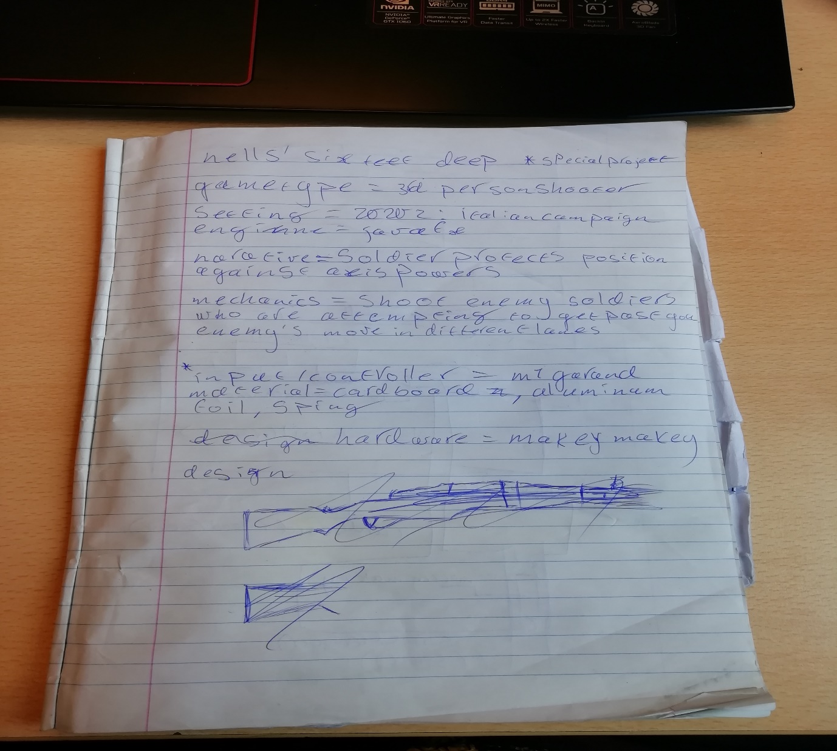
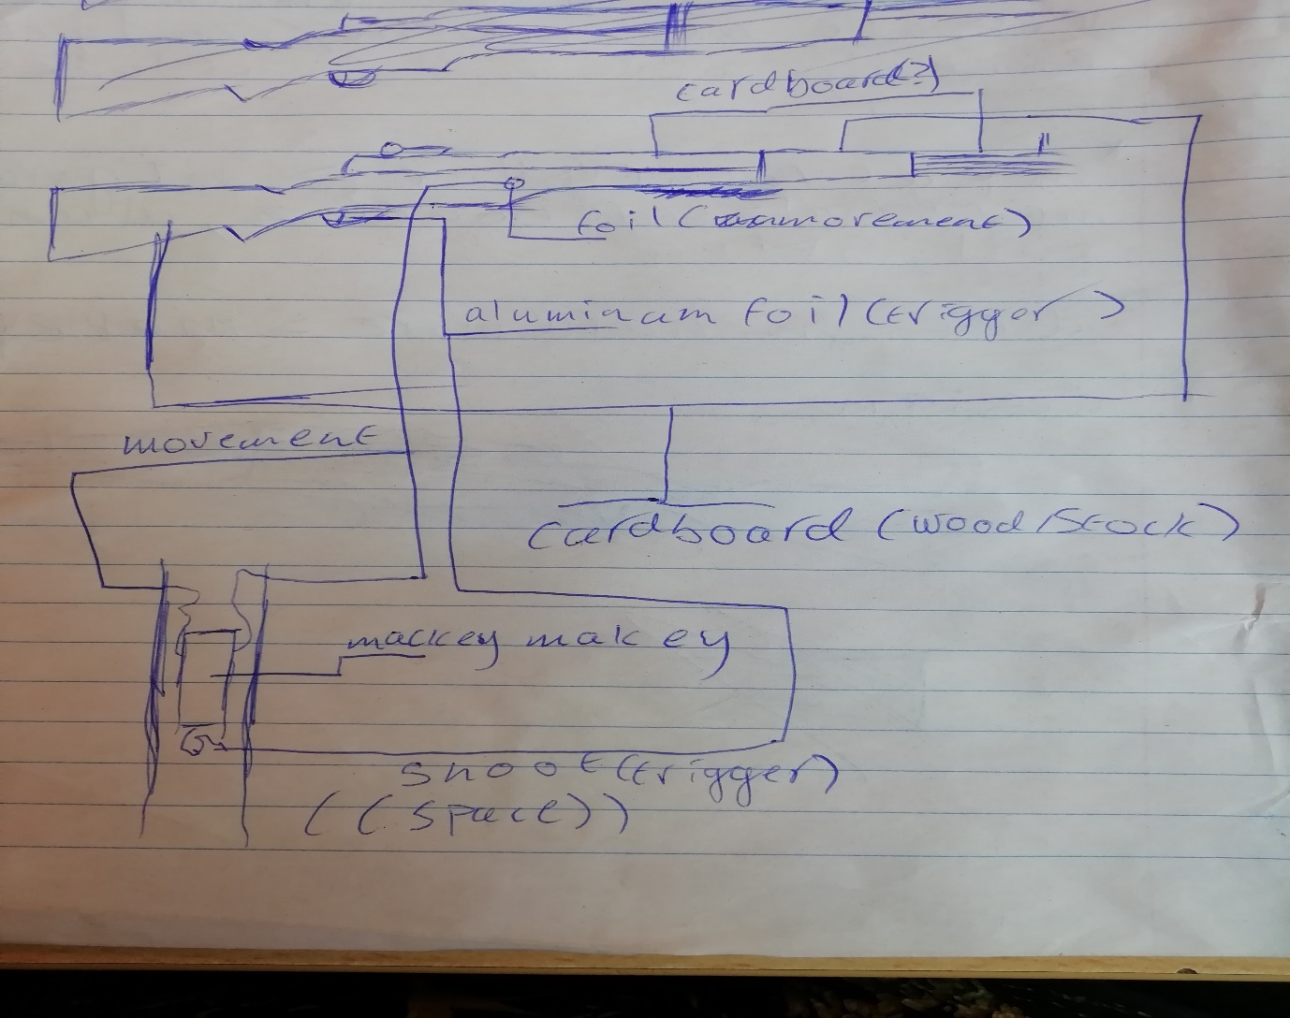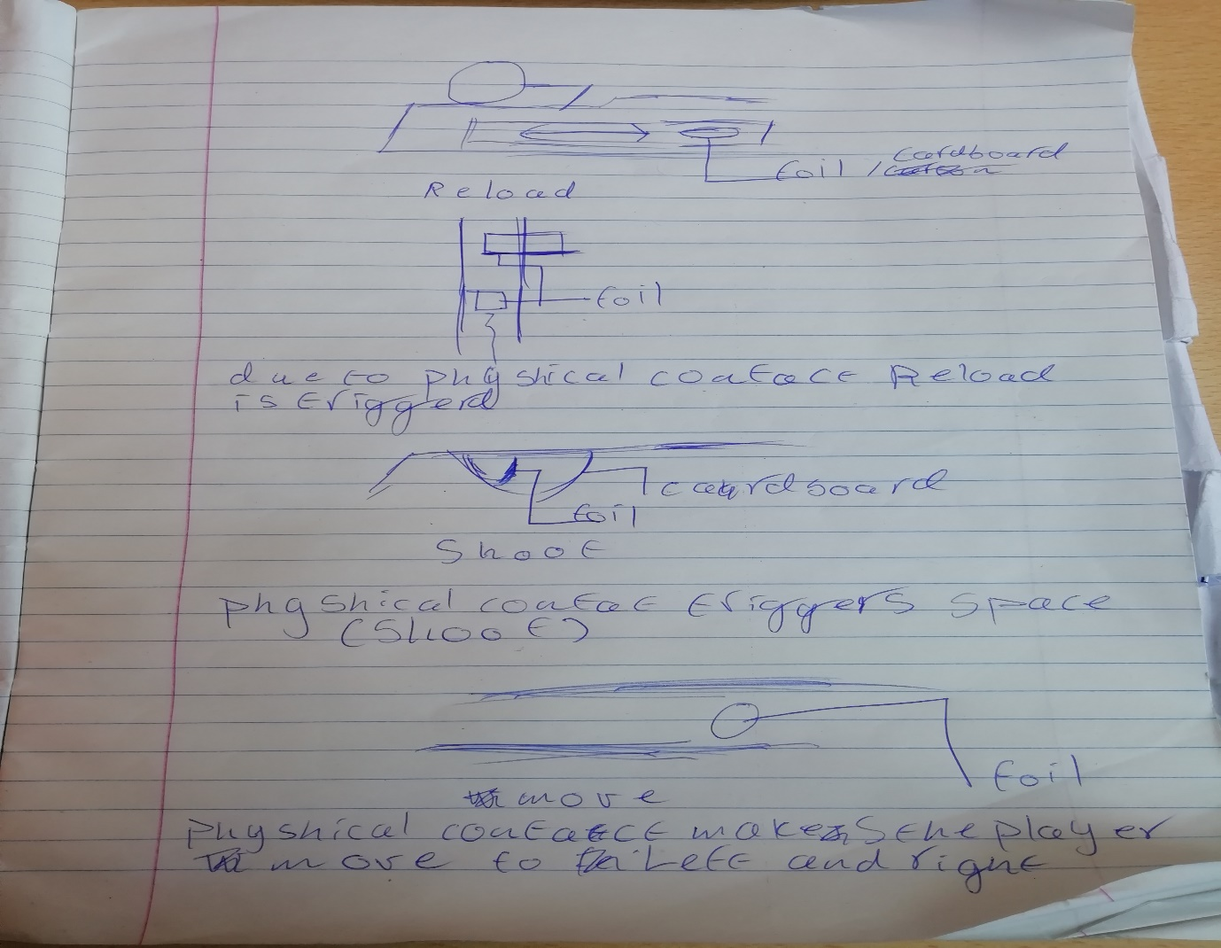

Speaks for itself.

Conclusion:

The gun will be the M1 Garand. The material will be carboard and duct tape
It will have movement buttons/areas on both sides, a trigger and a reload system.

I am not good at arts and crafts, but we’ll see how it goes.

